P6B Space Mission Update (aka Term 3 Newsletter)

Attention all families:
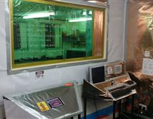
Your child has been selected for an important mission of the utmost scientific importance. I am proud to announce the development of the Fishermoss P6B Space Programme. The classroom is currently undergoing significant refurbishment whilst we install the high tech control panels that will facilitate our voyage into space. Over the next 11 weeks we will be undertaking research into space travel, space suits, the Solar System, galaxies as well as the history of space exploration.

Maths
Apart from the important calculations to do with escape velocity and Space/Time theory discussed by Chief Science Adviser Mrs Middleton, we will also be investigating two and three dimensional shape, time and angles. There will be as much connection to real-life contexts as possible.

Language
During the term the astronauts will be working on some more creative writing as we explore the Big Writing resources. There will be a focus on grammar, handwriting, spelling and punctuation as well as including exciting new vocabulary in their texts.
The reading groups will be heard on Mondays where a book detective will also be given home. Reading groups will also be heard on Thursdays where further reading will be given but no book detective.

Visiting specialists
Mrs Middleton has been appointed as our Chief Science Advisor and will take the class on Friday afternoons. Her background in astro-physics means that she can provide answers to almost any question the children may have about the universe.
We also expect Mrs Ruxton to return as our French Specialist and she will take the class on a Friday morning.
I will continue to take the class for P.E. where we will be following the ‘Mission X’ program, investigating how astronauts prepare their bodies for space. We have also been lucky enough to have ‘MC’ visit the school to provide a Hip Hop dancing lesson which can now be seen on GLOW and we also have a coach from the Aberdeen Football Club Community Development Trust working with the class for three sessions.
Please ensure that your child has suitable, clean kit for PE and that gym shoes are in a good condition. Children have had some problems recently with indoor shoes that don’t fasten properly and can be dangerous.

Technology
All children have a GLOW login and there is more content on the class GLOW page. Please ask your child to show you.

Finally, I know that the changing area is very confined and the children understandably find it difficult to keep it tidy. If you could provide a bag for indoor shoes to be kept in and hung on a peg then it would make life a little easier.

If you have any questions please feel free to get in touch with me via the homework diary or the school office.

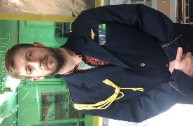
Thanks,
Commander Barrow
Fishermoss P6B Space Programme, Earth division.

