P6B Term 4 Newsletter

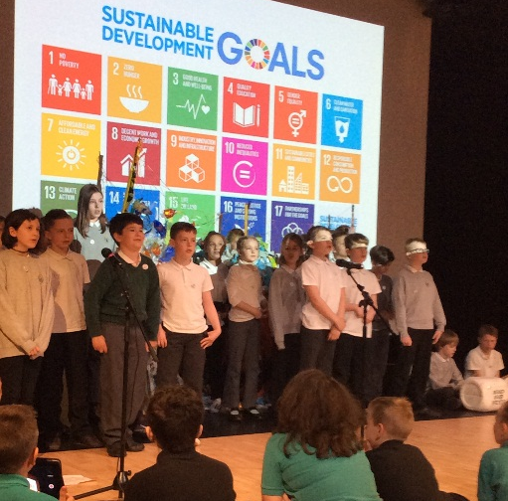
As with many missions, last term’s space project didn’t quite go to plan. Whilst exploring the depths of space, the Solar System, space travel technology and the possibility of life on Mars, we found ourselves looking back to earth and exploring the Global Goals and sustainable development our own planet. Therefore, we have a few loose ends to tie up before we begin our new focus for this term. We aim to begin our new topic in a week’s time.

Term 4 Topic
Blending together aspects of geography, citizenship, science and technology, we will be exploring the true story of William Kamkwamba from Milawi, Africa. When he was 14 his family suffered starvation during the 2002 drought and he thought differently to create a practical solution. The class will be comparing life between our two countries and looking at how we can develop technology in a sustainable way too.
Have a look at these videos for more info: www.ted.com/talks/william_kamkwamba_on_building_a_windmill
https://www.ted.com/talks/william_kamkwamba_how_i_harnessed_the_wind

Language
We will continue to write a range of creative and functional writing this term whilst focusing on grammar and handwriting as well as keeping up our work on Vocabulary, Connectives, Openers and Punctuation. Homework will still be given in the form of reading and Book Detectives and we will endeavour to read together twice a week, on a Monday and Thursday.
Maths
This term we will continue to develop children’s ability to read and solve problems using time. We will also be looking more into data and analysis using graphs, charts and looking at patterns and averages. We hope to consolidate much of our learning through practical applications in our topic and through racing car simulation towards the end of the term. It is likely that maths homework will be sent home to allow for practical tasks in class.

Visiting specialists
Mrs Middleton continues to deliver Science on Friday afternoons and will help us learn about sustainable energy productions and electric circuits.
Mrs Ruxton will deliver French on a Friday morning.
I will continue to take the class for P.E. where we will be developing our fitness and athletics in preparation for Sports Day. This will be delivered around the Bikeability provision which will begin in May and run for 7 weeks. You should have had the letter and booklets home by now. If you have not seen them then please get in touch.
Please ensure that your child has suitable, clean kit for PE and that gym shoes are in a good condition.

Technology
We continue to use GLOW as a tool for collaborative working, sharing our achievements and showing off to parents. If you have not seen our class glow page, ask your child to log in. There will be more comments, news and photographs published throughout the term.

Bikeability
As per the letter home, Bikeability will run from 2nd May for seven weeks. Each class will have a 1-hour session on Tuesday morning and a 1-hour session on Wednesday mornings. It is extremely important that parents have checked the bikes and helmets for safety before sending them to school as any delay caused by unsafe bikes might mean the series of sessions cannot be completed in time. We are also keen to have more parent helpers so if you are PBG registered and free to help then please let me know.

As usual, if you have any questions please feel free to get in touch with me via the homework diary or the school office.

Thanks,
Mr Barrow
Fishermoss P6B

