

Fishermoss School

**‘Being the best we can be’**

**Other Sources of Information On My Child’s Learning & Progress**

Information about school events, topics, visits & what your child is covering in school can help to open up discussion about their learning at home. This will help to build a picture of your child as a learner in addition to the specific information you receive in reports and at parent/teacher consultations.

**School Events**

* Class assemblies & Performances
* Open afternoons and evenings
* Sports Day
* Church Services
* Parent information meetings
* Curricular Evenings
* Parent/Pupil/Teacher interviews

**Other**

* Class & school newsletters
* Homework diaries
* School website

The **National Improvement Framework** emphasises the value of ensuring parents/carers are supported to enable you to play an active role in your children’s learning and achievement. We will continue to populate our school website with ideas on how you can support your child in their learning.

[**www.fishermoss.aberdeenshire.sch.uk**](http://www.fishermoss.aberdeenshire.sch.uk)

**WHERE ELSE CAN I FIND   
INFORMATION TO HELP ME FIND   
OUT ABOUT MY CHILD’S PROGRESS?**

**PARENTZONE**

A website for parents giving information about education in Scotland and ideas to help parents support their children's learning.

**Learning at Home Page (Parentzone)**

* **What can I do as a parent?**
* **Supporting Literacy/Numeracy/Health and Wellbeing at home.**
* **Learning through play**

[**http://www.educationscotland.gov.uk/parentzone/learningathome/index.asp**](http://www.educationscotland.gov.uk/parentzone/learningathome/index.asp)

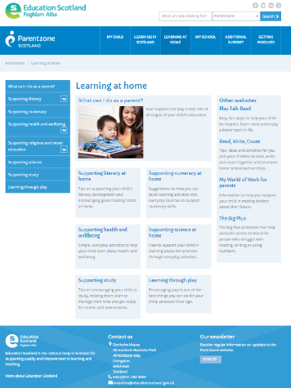

Finding Out More About Your Child’s Learning

A Guide for Parents/Carers

Your child is like a living report!

In school, we help your children to *understand* their learning in order to know how well they are doing. This enables them to talk about it in an informed way.

They, in turn, can help you to understand more about their learning and talk to you about how well they are doing.

We hope this leaflet helps you to find out more about their progress in learning.



**Asking your child the right questions will help you get more information about:**

* ***your child’s understanding of their own learning***
* ***how they are progressing and managing their learning***

# **What kind of questions could I ask my child?**

**About activities**

* What activities did you do today?
* How did you know what to do?
* What was your role in the activity?
* What/who were you working with today? How did it go?
* What equipment/tools did you need? Can you use them?
* What skills were you learning to do?
* What was the best/worst thing you did today?
* Did anything happen which you didn’t expect? What?

**About your child as a learner**

* Tell me one/two/three thing(s) that you know now that you didn’t know this morning.
* Tell me about a mistake you made today/this week and what you’ve learned from it.
* What did you find difficult? Why do you think so?
* If you did the task again, what would you change and why?
* Can you teach me something you’ve learned?
* Tell me something you learned that you are proud of.
* What did you expect to happen when you started the task? What did happen?
* What did you find challenging about the activity/lesson?
* What do you do if you’re not sure about something?
* What surprised you about how you learned?

# **What kind of questions could I ask my child?** *(continued)*

**How they use their learning**  
These examples might be specific to a subject *e.g measure.* However, you could use the same questions for different areas of the curriculum.

* What kind of a learner do you think you are?
* How did you arrive at your answers?
* When do you think you might use that/those skills again?
* What other ways could you use what you learned?
* What kind of things could that learning help you with?
* Who might use those skills in their job?
* Why do you think learning to measure/read/count accurately is important?
* Why do you think it is important to learn about ……?

**About their ‘Learning Celebration Book’**

* Tell me about your achievements this term.
* What are you most proud of and why?
* Why have you chosen………..as your target?
* What made you choose these samples of work?
* How do you think I can help you in your learning?
* Let’s think together of some personal achievements you can add to your Learning Celebration Book.
* Let’s look back through your Learning Celebration Book together and see the progress you’ve made.

The time you take to talk to your child about their learning helps to consolidate their thinking, gives them opportunities to clarify their strengths, recognise their achievements and helps them to identify next steps. Please take the time to comment on their Learning Celebration Book and the discussions you have shared about their learning and progress.

**Some other tips to encourage your children to talk about their learning.**

* Choose the right time to talk – *a relaxed atmosphere is good*
* Choose the right place to talk – *away from technology if possible for both* *parents and children!*
* Make/plan time to talk
* Try to ask open-ended questions –  *avoid ‘yes’ or ‘no’ answers!*
* Avoid the *‘interrogation’* scenario
* Don’t ask too many questions at once
* Make sure to *‘listen’* to what they are saying or answering
* Support and praise
* Encourage your child to ask ***you*** questions about your day too