P4/5 Newsletter January 2020

Dear parents/carers,
I would like to wish you all a very Happy New Year and trust that you enjoyed some time over the holidays enjoying catching up with family and friends. The children have returned with lots of news and ready for the term ahead.
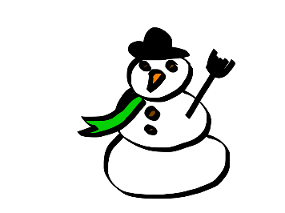
In Literacy this term the focus will be on reading a variety of texts to develop note taking skills and to read for different reasons. All children require a personal book to read, to be taken to school daily or left in their tray, as they develop skills for reading for enjoyment and concentration with regular silent reading opportunities. (The book can be one they have chosen from the school library or brought from home). The main focus in writing will be proof reading and presentation as well as personal targets set through self and peer assessment. There will be opportunities to develop listening and talking skills with individual prepared presentations, presenting in groups to the class and others, learning about different methods of sharing information and questioning skills.
P4 will be extending their knowledge of multiplication linked with division and fractions in Numeracy. P4 will be looking at the connections between the tables and develop strategies to support their knowledge and use of tables in different situations. P5 will be using their knowledge of multiplication to multiply 2 digit numbers by 1 digit. They will also be linking this with fractions and division to explore the uses of tables in different areas of maths. Another area of Numeracy to be taught this term is shape. P4 will be learning about properties of 2 and 3D shape, describing them with appropriate vocabulary and identifying their uses in the world around them. P5 will be extending their knowledge of shape by looking at and creating nets and making simple 2D shapes with more accuracy by using their knowledge of the properties of shape and measuring skills. The children will also be learning some maths using French words and phrases.
In Health and Wellbeing the learning will be about both positive and negative emotions and how they affect our own and others’ behaviour and reactions in different situations. Part of this will be learning about effective self-assessment, how the children feel about their learning and being involved with planning and next steps. Extending on from self-assessment, the children will be exploring and identifying strengths in themselves and others and using these strengths when working together.
In Social Studies the children will be learning more about the geography and wildlife of the local area including conservation, land use and planning for wildlife, jobs associated with wildlife and habitats, making informed decisions using appropriate evidence and current scientific news and the connection this has on their own lives etc. This topic will encompass many curricular areas. The children will have the opportunity to plan for learning, knowledge and skills within this context. If you have any suggestions of activities or learning opportunities, please share your ideas by making a note in your child’s homework diary or discuss it with them so they can add your ideas when the class plan their learning (Talk homework has been issued today to support this).
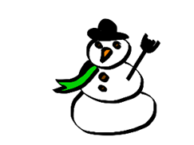
Weekly
Monday –
- PE – ball control in volleyball (all children require PE kit)
- French– classroom objects, classroom conversations and French alphabet (Miss Ruxton).
- Assembly
Tuesday –
- Art – (all children require an art apron/something to protect clothes)
Wednesday –
- Science – electricity, senses and other body systems (Mrs Rennie)
- PE – running (all children require PE kit
- Library (fortnightly beginning 14/1/19)
Friday –
- Golden Time- children are welcome to bring a toy or game in to share with peers. No screens please)
Dates for your diary
Wk beginning Mon 27th January -Interim Pupil Report being issued by the end of this week & Learning Celebration Books go home.
Mon 3rd February – P4/5 Class Assembly, 2:45pm
Thu 13th, Fri 14th and Mon 17th February- Mid Term Holiday-School closed to pupils and staff.
Tues 18th & Wed 19th -Staff In-Service Days-School closed to pupils
Fri 21st -School Photographer-Sibling Photographs
Fri 13th March–Sports Relief ‘Dress as you Please’
Wk beginning Mon 30th March–Effort/Attitude/Behaviour comments homework diaries.
Fri 3rd April -Last day of Term

Homework
The homework pattern will alter slightly from last term with reading taught and reading and book detective homework set on Monday and Wednesday or Tuesday and Friday. Other homework will be issued on Wednesday along with spelling to be completed by the following Wednesday. Talk homework might be issued over a shorter period but this will always be stated when necessary. Regular mental maths practice is always a benefit so please remember to use maths when you are out and about, log onto Sumdog, calculate a shopping bill or use any other opportunities which arise. Similarly, with reading and literacy, use opportunities to get children to read in different contexts whether it be timetables, cinema viewing times, recipes, instructions etc.
There are also links on the Glow Page to other useful websites, pictures and information about your child’s learning for them to show and discuss with you.
If you have any questions, concerns or queries please get in touch either at the door, telephone or write a note in your child’s diary.
Yours sincerely
Mrs Fiona McRae

