Hello everyone,
This week the nursery teachers have been working at the Hub at Hillside School and had lots of fun with the children there.
On GLOW we have uploaded lots of videos for you. Miss Parker put a video up of what she saw on a few walks around her home. Miss Parker’s favourite thing that she found was a duck. We would love to see what you can find on your walks around your home.
Mrs Garden has created a folder called ‘Pets’ and she put a video about one of her pets, a budgie called Whiskey. We would love to see what kind of pets you have in your house! You could upload a picture or a video of the pets you have and how you look after them.
Mrs Milne has uploaded a video of her reading ‘Pirates love Underpants’ which is in the literacy folder. She even reminded us about the parts of a book, can you remember what the person is called who writes the book?
Miss Strang has uploaded a link for you to follow for ‘Sticky Kids’ CD which the children love taking part in on rainy days. There is also more ideas for loose parts in the ‘Invitation to Play’ Folder.
We all hope you have a lovely weekend, more videos will be uploaded onto GLOW next week.
Miss Anderson has also added a Primary 1 folder where she will put any correspondence for our children starting school this year.
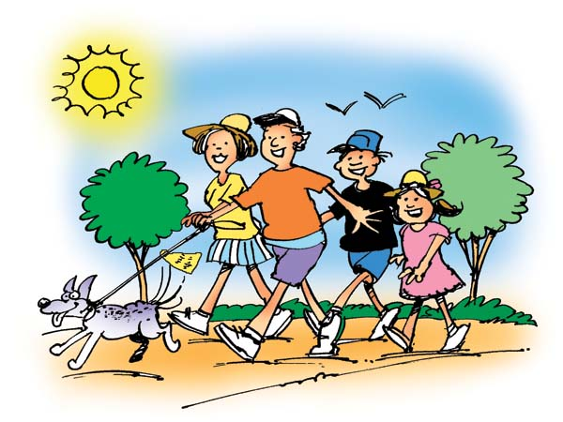
Stay safe,

Nursery Team x

