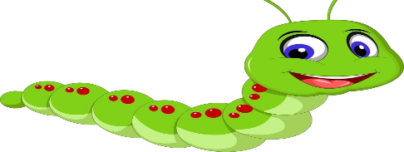

Hello everyone,
I hope you are all doing well and enjoying the sunshine outside. This week we have been working at the hub and it has been great enjoying the sun with them.
In the Maths folder, there are some numeracy worksheets relating to the Hungry Caterpillar and counting how long his body is. We have uploaded a shape activity sheet where you can fill in a graph, if you’re finding this a bit tricky you could learn about what shapes are on the activity.
In the Literacy folder Mrs Garden uploaded a video of herself reading the Hungry Caterpillar. Sometimes the video does not come up but if you have the Hungry Caterpillar book at home you can follow using that.
In the Science folder there is very easy instructions on how to make a hoop glider. All you need is an old cereal box and a plastic straw, Mrs Milne even coloured her one in.
In the Video folder there is a video of how to use shaving foam in a different way by shaving foam print painting. Looks like so much fun!
Hope you all have a lovely weekend and maybe see some more family members but always remember stay 2 meters apart
Stay Safe, Nursery Team!

