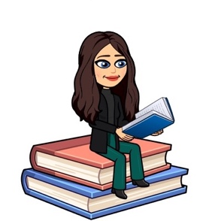

November 2020
Primary 5 Newsletter
Dear Parents/Carers,
I hope you all had a lovely October break. I can’t believe that is us in term 2 already! The class have settled in well and are looking forward to our learning this term.
It was lovely to talk to you all during our parent consultations before the holidays. This term we will be sharing our learning through google classroom on November 10th for our show & tell curricular evening. Your child will be able to show you pictures of our class learning and discuss this with you at home. Children will be bringing home their Learning Celebration books too. We encourage you to talk about their learning at home. Please return the book to school after you have seen it.
Reminders:
- Pupils are encouraged to take a pencil, rubber and any stationery items they wish to school, PE kit, water bottle, and a jacket. Children should not bring toys from home. Could I ask children to bring a book of their choice for free reading in class. This allows the opportunity to discuss what they enjoy reading with others.
- Children should also bring their reading book and homework diary each day. If you are sending in a note with your child in their diary, please encourage them to bring the note to the teacher.
- This term we will continue to have P.E on Tuesdays and Thursdays. This will continue to take place outdoors. Could I please encourage pupils to be appropriately dressed for outdoor exercise.

- Weekly timetable:
Monday: | Writing (please check homework diary for weeks that there is Big Talk homework to support writing in class).  Assembly
Tuesday: | Spelling words issued in homework jotters to practise at home.  RME with Miss Mellis (fortnightly)  French with Miss Ruxton  P.E with Miss Ruxton (Please remember PE kit)
Wednesday
Thursday: | P.E (please remember PE kit)
Friday: | Golden Time

Dates for the Diary
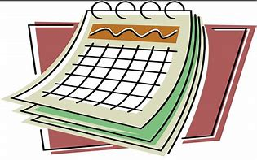
- Monday 26th October – Start of Term 2
- Fri 6th Nov-Rotary Shoe Box Appeal-last day to return boxes to school
- Tue 10th November – Pupil Show & Tell Curriculum Event (on-line).
- Friday 13th November - Children in Need Dress as You Please Day!
- Friday 20th November - Staff In-service Day (school closed to pupils)
- Wed 2nd December -Flu vaccinations
- Friday 18th December - Last day of Term 2
- Tue 5th January 2021-Term 3 begins!

Homework
- I have created a Google Classroom for our class this year which all children can access through glow by clicking onto the Google Classroom tile. I will be uploading any homework to our online classroom including our weekly spelling words, Big Talk homework to support writing in class and any maths activities. If you have any problem accessing google classroom at home please let me know
- Spelling will be taught in class every Tuesday. A list of spelling words will be in their homework jotter and uploaded to Google Classroom to practise at home. Spelling will be revisited throughout the week so please ensure children bring their homework jotter everyday.
- Reading will be heard in class throughout the week and will be noted in their homework diary along with a Book Detectives activity. Please ensure children bring their reading books and homework diary everyday to class.

Our Class Charter
Primary 5 have worked together to create our own class charter. We decided on the following statements for class charter:
- Always try your best, don’t give up and ask for help when you need it.
- Listen to the teacher and each other.
- Keep the classroom tidy and remember to wash your hands.
- Put your hand up when you want to speak.
- Treat others how you would like to be treated and include everyone.
- Care for each other, be kind and have fun!

Please take the time to read and discuss the Golden Rules with your child, and sign the rules in their homework diary.
Numeracy
This term in maths we will be focusing on:
- Estimation and rounding numbers.
- Angles, symmetry and transformation.
- We will also continue to develop our mental and problem solving strategies.

Literacy
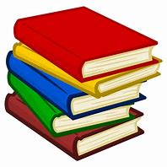
This term in literacy we will be focusing on:
- This term we will focus on both imaginative and functional writing. We will be looking at reports and survey findings relating to our class topic. We will also be focusing on taking our own notes using a variety of different sources relating to our class topic.
- Our literacy work will also link with our new class novel ‘The Boy at the Back of the Class.’ This novel will also link to our health & wellbeing and circle time discussions.
- We will also continue to use Jolly Grammar to develop spelling and grammar skills.

Topic
Our topic for term 2 will continue to focus around wildlife and habitats. This term our topic focus will be on pollution and conservation and the environmental impact of human activity. As a class we will discuss and suggest ways in which we can live in a more environmentally responsible way. We will be looking at appropriate evidence including reports and survey findings to make informed decisions.
Health and Wellbeing
This term, we will be focusing on relationships and getting along with others. We will be able to link our circle time discussions to our class novel.

If you have anything you wish to discuss, please don’t hesitate to get in touch through the diary, or phone and I will call back.
Kind regards,
Emily Blacklaws

