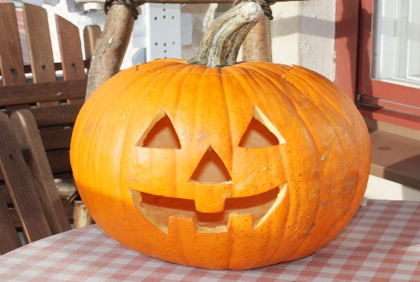
October 2020 Newsletter
This Photo by Unknown Author is licensed under CC BY-SA
Dear Parents/ Carers,
We are so pleased to welcome everyone back to Fishermoss after the October holiday. We hope everyone had fun and was able to spend some time with family and friends during the break, working within the current restrictions. All of the children have quickly settled back into the class routine and seem keen and ready to learn!
This newsletter should give you an overview of what we will be learning about this Term. This is always a busy and exciting Term for the children as we move towards Christmas. If you have any questions or concerns at any point during the Term, please phone the school and we will get back to you as soon as possible. Please remember that we will not be able to come to the phone when we are teaching the class. Alternatively, you can write a note in your child’s yellow homework diary as these are checked most days for any correspondence.
Timetable
- Mrs Bryson is the class teacher on Monday/ Tuesday and Mrs Cameron is the class teacher on Wednesday/ Thursday/ Friday.
- PE is on a Monday and a Friday each week. P.E. will continue to take place outside and, as we move into the colder months of the year, please ensure that your child is dressed appropriately for outdoor gym lessons.
- Mrs Storey will be in the class on a Tuesday morning and will be teaching RME.
- Mrs Bryson will be in the class first thing on a Wednesday morning up until break time and will be teaching practical maths. Please note, Mrs Bryson will collect the line on a Wednesday morning to bring the children into school.
- Mrs Bragg will continue to support our class as a PSA for periods of time throughout the week as well as supporting one of the Primary 1 classes.
- Golden Time will continue to be on a Friday, and we would remind pupils not to bring items in from home for Golden Time or on other school days.
Curriculum
This Photo by Unknown Author is licensed under CC BY
Literacy
- Reading will be heard in class two or three times a week and we will also complete reading related tasks to help the children to develop a variety of reading and comprehension skills. Please remember to hand back reading books on the day specified as these need to be quarantined for 24 hours before they can be made available to other pupils and classes. Most pupils have made super progress in reading during the first Term and are now back on track following the extended break when schools were closed. We will be encouraging pupils to apply their reading skills when they complete other tasks, for example, to read information on the board or instructions in their maths workbook.
- Pupils will continue to develop their knowledge of sounds and blending sounds together to build words. Most pupils will continue learning about joined sounds and how to apply this knowledge to spell more complex words. During grammar tasks, most pupils will be learning about nouns and proper nouns, verbs and how to use the past tense. We will also be revising alphabetical order.
- In writing this Term, we will focus on learning how to write clear, detailed instructions to explain how to complete a variety of simple tasks or games. All pupils will be encouraged to write as independently as possible and to apply what they have learned during grammar lessons when completing written tasks.
Numeracy
- Most pupils will continue to practise addition and subtraction within 20, exploring mental strategies and the use of concrete materials, such as a number line, to help them work out the answers. Pupils will also complete tasks related to smaller or larger numbers as appropriate to their level of knowledge and recall, practising reading larger numbers, partitioning them into Tens and Units and working out if they are odd or even. We will also be practising how counting on and back in 10s, 5s and 2s.
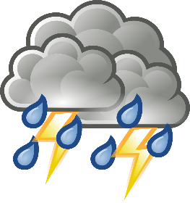
- Mrs Bryson will complete weekly practical maths tasks linked to topics such as data handling, shape, or money, for example.
This Photo by Unknown Author is licensed under CC BY-SA
Topic
Our topic this Term is Weather and we will learn about forecasting the weather, how to prepare for different types of weather, how the water cycle works, how climates differ in other places and how this impacts upon the environment of these places. We will continue to learn about Night and Day during science lessons and explore science topics which link to weather and weather forecasting. We will also be learning about the Christian celebration of Christmas and will have lots of fun completing various art and craft tasks in preparation for Christmas.
Homework
- Spelling/ Phonics homework will be sent home once a week.
- Reading tasks will be set and recorded in the homework diaries. On occasion, because of Bank holidays or Inservice days, your child’s reading days will be different to the normal days, but this will be clearly recorded in your child’s homework diary.
- We will not be sending home written maths homework this Term but would encourage you to continue working with your child to develop their mental maths skills. A separate sheet will follow in the next week or so with suggestions of what you could practise with your child.
Helpful tips/ reminders
- Welly boots can be worn on wet days but please put another pair of shoes into your child’s bag for them to change into when they get to school.
- We will be washing hands regularly throughout the day and using hand sanitiser. If you are concerned that you child’s skin may be affected, then please supply sanitiser that you are happy with or hand cream that your child can apply themselves after washing/ sanitising. Please ensure any such items are clearly labelled with your child’s name and class.
- Please supply your child with a freshly filled water bottle each day as this will mean they won’t need to access the water fountain to have a drink. Remember that water is the only drink which can be taken into the classroom and to clearly label your child’s bottle with their name and class.
- Labelling all school clothing and shoes is useful even though pupils won’t be changing for gym. It would amaze you how things can go walk about! Labelling outdoor jackets is also useful as children do accidentally leave jackets outside if they take them off after getting too hot and forget to bring them back in. If they are clearly labelled, it is much easier for the jacket to find its way back to the owner!
Dates for the Diary
- Fri 6th Nov-Rotary Shoe Box Appeal-last day to return boxes to school.
- Tue 10th Nov – Pupil Show & Tell Curriculum Event on-line. Learning Celebration Books go home!
- Fri 13th Nov- Children in Need Dress as You Please Day!
- Fri 20th Nov - Staff In-Service Day-School closed to pupils.
- Wed 2nd -Flu vaccinations.
- Fri 18th - Last day of term 2.
If there is anything we can help you with or something you wish to discuss, please don’t hesitate to get in touch,
Best Regards
Mrs Bryson and Mrs Cameron

