P4/5 Newsletter April 2021

Dear parents/carers,
It has been lovely to welcome all the children back for the start of term. They have returned with news of their holidays and ready to start learning.
In maths this term the children will be continuing work with their multiplication, with P5 working with multiplying 2-digit numbers by 1-digit numbers, prime numbers and factors whilst P4 will be working to consolidate their knowledge of the 2, 3, 4, 5 and 10 times tables and extending to the 6 and 8 tables. Linking division, division with remainders and fractions will also be an area for P4 will be working on. P5 will be extending their knowledge of division beyond their tables, using their knowledge of tables to calculate division up to 3-digits. Shape will also be an area of maths the class will be working with this term. The focus for P4 will be describing 3D shape using 2D shapes, exploring angles and identifying right angles. P5 will also be exploring and identifying different angles in shape and using nets to investigate 3D shape.
Literacy this term will focus on fluidity of language. The children will have opportunities to explain why written texts are successful, share their opinion, summarise and take notes from different sources. This will be reflected in the writing opportunities where the main areas for learning are creating different texts for different audiences, successful use of punctuation, combining words and images and self-checking to make sure writing makes sense. In reading, P4 will be learning more about inferring meaning into what they are reading, creating their own questions and giving opinions with P5 extending this to include summarising unfamiliar texts.
There will be a lot of group work this term to give the children an opportunity to enjoy being back learning together and work on collaborating, cooperating, taking responsibility and many other skills involved in these types of tasks. Health and Wellbeing will also include talking about and sharing feelings and thinking about how to help themselves or get support when they feel they need it. Following on from the body science tasks completed during remote learning, the children will be learning more about changes in their bodies as they grow and develop. This website ( https://rshp.scot/) will give you more information about what will be discussed in these lessons. They will also be learning more about how to give or use feedback to improve their work.
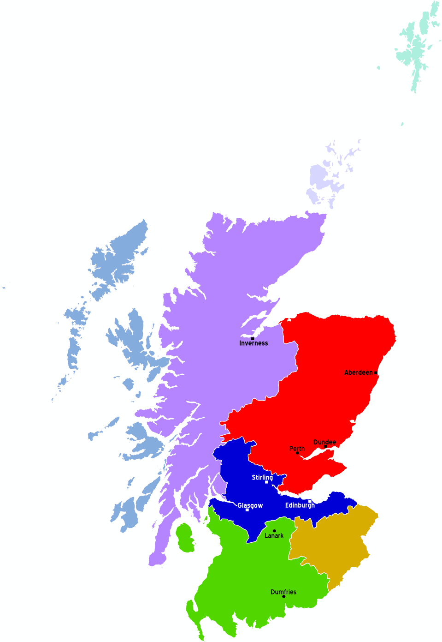
The Social Studies topic of ‘A Journey around Scotland’ will be continued this term. We have travelled to the Northern and Western Isles so far, so there is plenty more of Scotland we need to explore! This will include investigating landscapes and land use, research skills, habitats and adaptation, map reading and investigating historical sites and evidence. If you have anywhere you think that we should visit on our travels, please write a note in your child’s homework diary.
The homework pattern will be similar to term 2 with reading taught and reading and book detective homework set on Monday and Wednesday or Tuesday and Friday. Other homework will be issued on Tuesday along with spelling to be completed by the following Monday. Talk homework might be issued over a shorter period but this will always be stated when necessary. Regular mental maths practice is always a benefit so please remember to use maths when you are out and about, log onto Sumdog, calculate a shopping bill or use any other opportunities which arise. Similarly, with reading and literacy, use opportunities to get children to read in different contexts whether it be timetables, cinema viewing times, recipes, instructions etc.
Weekly:
Monday – PE- The children can come to school dressed for PE or take clothes with them. Outdoors PE will be orienteering and athletics.
Assembly
Tuesday – Spanish. (Miss Ruxton will be teaching letters, numbers and colours and simple greetings)
Art – All children need an art apron/old t-shirt or something similar
Wednesday – PE. Mrs Sayer will be teaching different racquet skills outdoors. The children can come to school dressed for PE or take clothes with them.

There are also pictures and information about your child’s learning on the class Glow page for them to show and discuss with you.
If you have any questions, concerns or queries please get in touch by email, telephone or write a note in your child’s diary.
Yours sincerely
Mrs Fiona McRae

