You and Your Child

How you can help with Reading and Writing

Dear Parents,
These ideas have been put together in the hope that you may find them helpful in supporting your child to develop and practise reading and writing skills through everyday activities and games. Reading and writing are very important for your child’s development and, because they are connected, it is helpful if you encourage your child in both activities. Becoming a better reader helps to make your child a better writer. Your involvement in supporting your child’s development is very important and we hope that you can find a little time to think and talk about reading and writing with your child. Talking to your child about any reading and writing you are doing will also help him or her to make sense of all the different types of written text in the world around us. It should be an enjoyable experience and related to real life so the more you can do in the course of your normal routine the better! Learning to read and write is an exciting challenge for children so it’s never too early to start sharing with them the fun they can have with words and books, crayons and pencils. They can learn a lot about reading and writing before they even start school.

You can use this little book in several different ways. The pages on the left-hand side give you some suggestions for reading and writing activities that you might do with your child. On the right, you can use the empty boxes like a dairy to record what you did with them on a particular day – what book you read, what song you sang or what recipe you cooked. On the other hand, your child might want to do their drawing and scribbling in the boxes or they might want to use them like a scrapbook and stick something in that they did that day – wrote a shopping list with you, bought a bus ticket, collected a leaflet. Whatever suits you best!

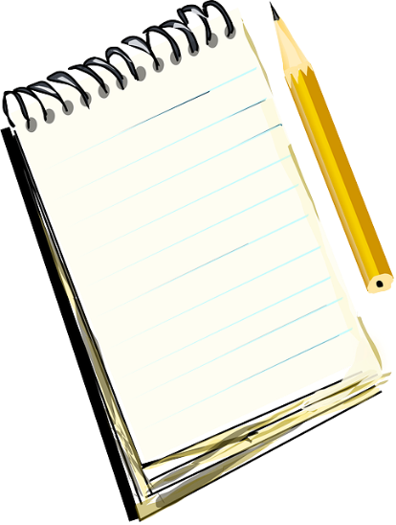

In the Kitchen

Spend some time looking through a recipe book with your child. Talk about what you might want to cook together.

When you have decided on a recipe, read through the list of ingredients together to check you have everything you need.

Read through the method together, getting out all the equipment you need as you go through the list.

As you are cooking, ask your child to think of lots of different words to describe what they are doing e.g. sticky, gooey, mushy, runny, lumpy.

When you have finished, write together on a post-it-note what you think of the recipe. How does it taste? Was it easy to make? You could then stick this note in the recipe book as a record of what you have cooked.

In the Kitchen

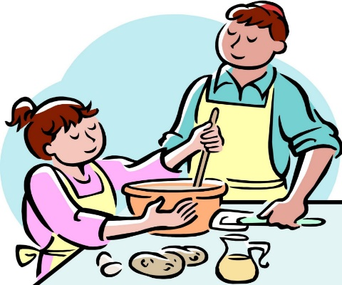
This Photo by Unknown Author is licensed under CC BY-NC-ND

Going Shopping
Before you go to the shops, sit together and write a list of all the things that you need. Perhaps your child could write a list as well on a separate piece of paper!

Before you go into the shop, point out to your child all the different signs around you and what they tell you: the name of the shop, where to park, where the entrance and exit are, where to buy petrol, etc.

As you walk through the supermarket, point out the signs above the aisles and the words on different packets and tins. Recognising the logo on a can of baked beans is a step towards recognising letters of the alphabet.

As you put things in your trolley, ask your child to tick or cross out the matching items on the list.

Ask your child to spot things beginning with a particular letter e.g. ‘s’ for soup, spaghetti, or soap. This should help them to start making links between sounds and letters.

Going Shopping

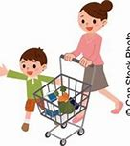

Keeping in Touch

Every week, you will get lots of different kinds of reading through your letterbox: postcards, letters, cards, bills, catalogues and advertisements. Show your child a variety of them, pointing out different features like the name and address of you and the sender.

When you have to write a birthday card, sit together with your child and explain what you are writing. Get them to ‘sign’ their name at the bottom.

Next time you use the telephone directory or the Yellow Pages, show it to your child and explain to them how to look things up, by using the alphabet and different categories. Show them the name of the company or person and the phone number next to it.

If they want to remind you to do something or get something for them, write a note together which they can then stick on the fridge as a memo.

After Christmas or their birthday, encourage them to sit with you and together write thank you notes for the presents they have received.

Keeping in Touch

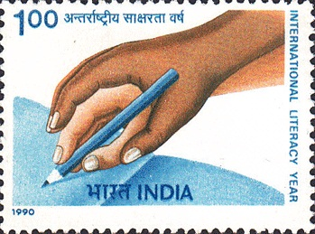

Going on a Trip

Plan an outing together. Discuss with your child where you might go and write down what you will need to take with you. Talking about what you are writing will help them understand the link between the spoken and written work.

As you travel, point out the road signs and explain what different ones mean.

If you are travelling by car, look at the map together and show them where you are going. If you go on a bus or train, explain to your child what the tickets are and get them to look after them.

As well as tickets, encourage them to collect other reminders of the trip such as leaflets or postcards. On your return home, you could stick them in scrapbook or put them in a special ‘memory box’.

As you look through the mementoes, talk to your child about the things you saw and did, writing them down as you go. They could draw a picture about a part of the trip, which you could label for them. This will help them see the difference between drawing and writing.

Going on a Trip

Playtime

Say, sing or listen to nursery rhymes, action songs and finger rhymes together. They will start to understand that words arranged in certain ways produce certain sounds and patterns. They will hear different rhymes and rhythms. It will also help them start to hear the words within a sentence and different sounds within individual words.

Play words games like ‘I Spy’ or ‘Treasure Hunt’: ask them to find objects around the house that start with the same sound or letter.

Thread wooden beads or build Lego towers. By seeing and copying them arranged in various colour combinations, children will learn how different patterns can be made. This prepares them for the idea that individual letters arranged in a certain order make patterns too – they make different words! They should see that patterns are not always random.

Encouraging them to develop their imagination will help your child with the quality of their writing. You can do this by giving them old clothes or material for dressing up. Get them to tell you who they are and what they are doing. Are they a policeman, a ballet dancer or an astronaut?

Make up stories with them about their teddy. Encourage them to tell you what should happen next in the story. What did Teddy do or say then?

Playtime

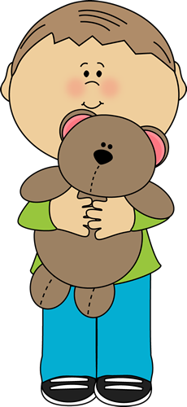

Drawing

When children first start to make marks on paper, drawing and writing are very much the same thing. However, as children develop, the two aspects become more distinct. Learning to draw is the first step for your child in realising that marks on paper mean something, both to them and to other people who look at their pictures.

You can encourage your child by asking him or her to draw a picture about a story they have just read with you.

Drawing also helps to build up hand control, which helps the process of learning to write. You can also get them to practise this by playing with building blocks, Lego, beads and playdough.

Have plenty of paper and crayons or pencils available for your child. Learning to scribble is an important step in a child learning to write. They will start to understand that writing goes across the page and not down and that writing is separated into different chunks i.e. words.

Show them how to make different shapes and patterns on paper as a starting point for forming letters later on. They will start to realise that a variety of shapes form different letters.

Drawing

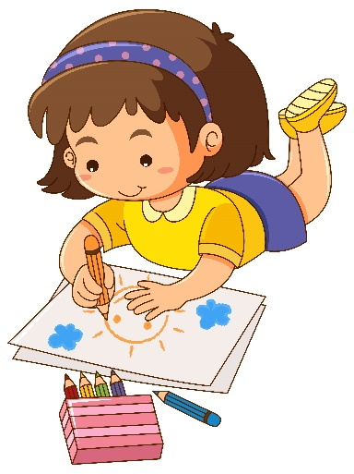

At the Library

Join the local library with your child and take them along as often as you can manage. Sit and read a book together in the children’s corner, even if you don’t take it home.

Try and borrow a book yourself so that they can see that you enjoy reading too.

You could bring them along to one of those free story-telling sessions for young children that most libraries have on a regular basis.

Before you go, make up a list of books that your child would like to get – perhaps ask the librarian to help you find them when you get there.

Keep a ‘Borrower’s Book’ with your child. In a little journal, write down the names and authors of all the books they have borrowed from the library at each visit. They could then put a star or a sticker beside the book they liked most on that visit or give it a score out of ten.

At the Library

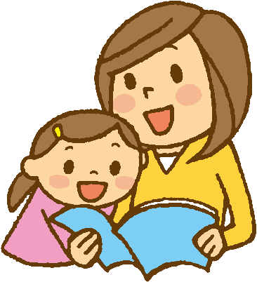

Story Time: Joining In

As experience with books grows, children often start to join in with phrases they remember. You can stop before the end of the line and allow them to take over.

Look at the front cover together and discuss what you might find inside.

At the bottom of the page, encourage your child to predict what will happen next.

When reading the story together, they might be reminded of the things that have happened to them or to their friends and family. They might also relate to other books they have read or things they have seen on TV. Encourage them to tell you all about this, even if it means that you have to stop telling the story for a little while.

At the end of the book, have a chat about it. What happened in the story? Was it a sad or funny or exciting book? Did they hear any interesting words? Which bit did they most enjoy? Encourage them to tell you why they liked it so much.

Story Time: Joining In

Story Time: Reading Alone

As children start to recognise the first letters of words and build up the bank of words that they recognise, you can help them in different ways.

If they hesitate when reading a word, repeat it or leave a word out, say nothing providing the whole sentence makes sense. Similarly, if they misread a word without changing the meaning e.g. ‘dad’ for ‘father’, accept this change.

If they are stuck or say a word which does change the meaning of a sentence you could help them by:

- Pointing to the picture
- Asking a question to remind them what is happening e.g. “Where are they going?”
- Re-reading the sentence up to the unknown word
- Saying or pointing to the first letter of the word
If they are stuck after these prompts, tell them the word to avoid losing the flow of the story or poem.

Story Time: Reading Alone

