Dear Parents/Carers

Bliadhna Mhath Ur-A Happy New Year!  I hope this finds you all safe and well!  This was not the start to the New Year we had hoped for, but the Fishermoss Family can do this together!

**This is one of those ‘make a cup of tea first’ Fishermoss Family Friday updates!  Then sit back and have a read………….**

Our pupils are in a really good place in terms of having caught up and moved on in their learning from the last lockdown. We want to keep the momentum going as best we can.  Lessons have also been learned from the last lockdown experience and no doubt we will learn some more this time. Learning is a journey and not a destination!

As part of their learner journey, all children and young people in Scotland are entitled to experience a coherent curriculum from 3 to 18, in order that they have opportunities to develop the knowledge, skills and attributes they need to adapt, think critically and flourish in today’s world.

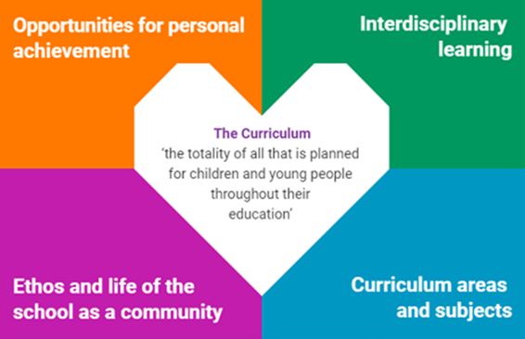

There have been a variety approaches to remote learning across Aberdeenshire and each will have advantages and disadvantages, but teachers have identified the best ways to support pupils over time, knowing that not one way will suit all pupils.

**What pupils can expect from Monday 11th January…….**

* A programme of learning and teaching will be shared on a daily basis by your child’s/ren’s class teacher, with the tasks for the day uploaded to their **Google Classroom** for 9am.  All classes will be using this platform.  There will always be a literacy, Numeracy and one other curricular area posted each day. Tasks will be differentiated as appropriate, as is the case in the classroom.

Please refer to the attached document **Remote Learning: Learner and Parent Responsibilities** from Aberdeenshire Council.This is a ‘one size fits all’ documentand covers Primary and Secondary pupils. The link at the bottom also takes you to ‘**Scotland Learns’,** a newsletter created for parents and carers with hints and tips, including learning activities that your child can complete on their own or that families can do together, a selection of these are included in each newsletter. You won’t need lots of resources and the tasks are designed to encourage children and young people's creativity.

* Class teachers will also provide a plan of what a full day of remote learning can look like for a child in their class.  This will signpost pupils to a suite of activities and links to resources to support learning with significant opportunity for personalisation and choice for pupils. These will be  emailed on Monday 11th January along with class newsletters.  Please also remember the activity links on our school website under ParentsàHome Learning.  We are in the process of finalising a dedicated Fishermoss website for Home Learning links.
* Interactions with their teacher / school staff.  From Monday 18th January there will be a weekly opportunity for each class to meet together virtually for a whole class activity through **Google Meet**.  This could be for a discussion on a piece of work they have had to prepare, a quiz on a topic or for a catch up together as a class.  Please see the attached guidance on how to access this facility and protocols.  We require permission from parents to authorise their attendance/participation in a class live Google Meet. If you are in agreement then please e mail [Fishermoss.sch@aberdeenshire.gov.uk](mailto:Fishermoss.sch@aberdeenshire.gov.uk) giving your child’s/children’s names and classes and state ‘I give permission’ or ‘I do not give permission’ for my child to participate.  There is no need to return the actual form.  **We’d be grateful if you could please have responses to us by Wednesday 13th January so we can progress this.**

Class teachers will inform pupils and parents in advance of when the live class Google Meet will take place for their class.  Teachers have coordinated the times of these so that where there are siblings in a household their Google Meet times aren’t clashing as we are aware pupils will be sharing devices with siblings at home. Miss Adam, our Additional Support for Learning teacher will also be setting up additional Google Meet sessions for pupil groups who receive extra support with reading, writing and spelling.

* Opportunities to ask their teachers questions in relation to their learning through Google Classroom and parents can also do so through Google Classroom or the class teacher’s GLOW email address.
* To receive effective and timely feedback on their work.
* To receive clear next steps / targets for their learning.
* The opportunity to give meaningful feedback on their remote learning experiences to ensure that provision meets their needs
* Pupils in P5-P7 could use this time as an opportunity to look into becoming involved in the Children’s University!  Pupils received a presentation about this at the end of last term and information was e mailed to parents.

Should you have any issues accessing the Google Classroom please e-mail your child’s class teacher directly.

For pupils who are at school, they will access their online learning here at Fishermoss on the days they are attending.

**Health warning…….**

The most important thing just now is everyone’s health and wellbeing!  We all have very genuine concerns in relation to the virus, the health of family members and friends, jobs loses and the associated financial implications of all that is happening.  Please do not add to these pressures by stressing about remote learning. Some parents will say it’s not enough provision and others will say it is too much, but you decide for your children what your family can cope with.  Everyone has very individual circumstances so try not to compare yourselves with others.  It will be our job to fill in the gaps when we return to school and we did a rather splendid job of that the last time!  You could all see through our **‘Curriculum Show and Tell’** how your children were thriving at school.  We’ll get back there!

Many of our families have both parents working from home so expect to take time to get a routine that works best for you.  As I have said before, it may be that after your working day is the best time to support your children with online learning or indeed the weekend.  Teachers are not expecting that pupils will have the work completed on a daily basis even though they are issuing it daily.  They know to expect work being submitted at different times of the day and week to fit in with family routines.  You will find a model that works best for you and your family’s circumstances.  Please be aware however to not expect replies from teachers in evenings and weekends!

We are here to support you and help in any way we can so please do not hesitate to get in touch.  We will all do our best and everyone’s best will look very different each day depending on the challenges we all come across!

Take care of yourselves and each other.

Kindest regards

**Margaret M. Ferguson**

**Head Teacher**

Fishermoss School

Berrymuir Road

Portlethen

Aberdeenshire

AB12 4UF

Tel:  01224 472875

Aberdeenshire Council Education and Children’s Services



**‘Being the best we can be’**

**Respect-Honesty-Responsibility-Kindness-Hardworking**