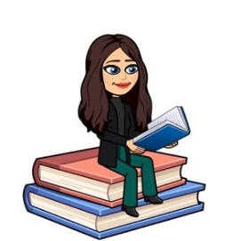

November 2021
Primary 4 Newsletter
Dear Parents/Carers,
I hope you all had a lovely October break. The class have settled in well back at school this week and are looking forward to our learning this term.
It was lovely to talk to you all during our parent consultations before the holidays. This term we will be sharing our learning through google classroom from Tuesday 16th November for our show & tell curricular evening. Your child will be able to show you pictures of our learning in class and discuss this with you at home.
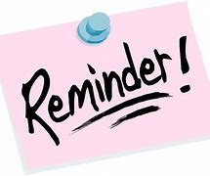
Reminders:
- Pupils are encouraged to take a pencil, rubber and any stationery items they require to school, water bottle, and a jacket. Children should not bring toys from home.
- Pupils can bring a book of their choice for reading in class. This allows the opportunity to discuss what they enjoy reading and author preferences with others. Books can be kept in their school bag or tray.
- Pupils should bring their reading book and homework diary each day.
- This term we will have P.E on Tuesdays and Thursdays. Could I please encourage pupils to be appropriately dressed for outdoor exercise.
- Pupils have the opportunity throughout the year to bring home their Learning Celebration books to share their learning and achievements with you. You are welcome to write a comment in their book then please return to school.

Weekly timetable:
Monday: | Spelling words issued in spelling jotters to practise at home.  French with Ms Ruxton  Assembly
Tuesday: | Writing  P.E
Wednesday
Thursday: | P.E with Miss Kevan
Friday: | Golden Time

We will also have Mrs Robertson supporting the work we do in class.
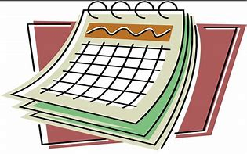
Dates for the Diary
- Monday 1st November –Start of Term 2
- Friday 5th November - Last day to return Rotary shoeboxes to school
- Fri 12th November - Children in Need Dress as You Please Day
- Tue 16th – Pupil Show & Tell Virtual Curriculum Event available from this evening!
- Thursday 18 November - Staff In-service Day-school closed to pupils
- Friday 19th November-Staff In-service Day-school closed to pupils
- Wednesday 24th November -Flu Immunisation Programme
- Tuesday 21st December- Last day of Term 2
- Wednesday 5th January 2022 – Term 3 begins!
Homework
- Spelling will be taught in class every Monday. A list of spelling words will be in their yellow spelling jotter to practise at home. Spelling will be revisited throughout the week so please ensure children bring their jotter everyday to school.
- Reading will be heard in class throughout the week and will be noted in their homework diary. Alongside reading, your child will be given a Book Detective task to complete. Book detective tasks can be found at the start of the homework diary (page 16) and can be completed in their homework jotter. Please ensure children bring their reading books and homework diary everyday to class.
- I will be uploading any other homework to our google classroom including our weekly spelling words, Big Talk homework to support writing in class and maths activities. If you have any problem accessing google classroom at home please let me know.

Our Class Charter
- Always try your best and don’t give up.
- Ask for help when you need it.
- Be kind and help others.
- Keep the classroom tidy and push your chair in.
- Remember to wash your hands.
- Put your hand up and listen carefully to others.
- Be happy and have fun!

Numeracy
This term in maths we will be focusing on:
- Applying knowledge of addition and subtraction methods when working with money.
- Properties of 2D Shapes and 3D Objects.
- We will also continue to develop our mental and problem solving strategies.

Literacy
This term in literacy we will be focusing on:
- Creating texts for different purposes and independently using the correct punctuation in our writing.
- Using our knowledge of spelling rules and resources to correctly spell common, tricky or unfamiliar words.
- Developing our understanding in reading and comprehension through responding to different types of questions on texts we have read.
- We will also continue to use Jolly Grammar to develop spelling and grammar skills.

Topic
Our topic this term is Scotland. We will be looking at Scottish landscapes, tourism in our local area and comparing Scotland to France. Through our class topic we will also look at the different types of food produced both locally and across Scotland and the importance of different types of agriculture in the production of these foods.
If you have anything you wish to discuss, please don’t hesitate to get in touch through the diary or contacting the school and I will call back.
Kind regards,
Emily Blacklaws

