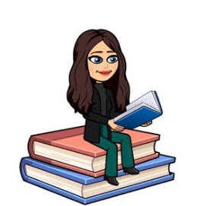

April 2022
Primary 4 Newsletter
Dear Parents/Carers,
I hope you all had a super Easter break. It has been lovely having everyone back to school and listening to all their holiday news.
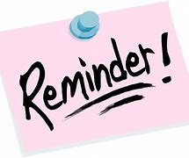
Reminders:
- Pupils are encouraged to take any stationery items they require to school, water bottle, and a jacket.
- Pupils can bring a book of their choice for reading in class. This allows the opportunity to discuss what they enjoy reading and author preferences with others. Books can be kept in their school bag or tray.
- Pupils should bring their reading book and homework diary each day.
- This term we will have P.E on Tuesdays and Thursdays. Could I please encourage pupils to be appropriately dressed for outdoor exercise.
- Pupils have the opportunity throughout the year to bring home their Learning Celebration books to share their learning and achievements with you. You are welcome to write a comment in their book then please return to school.

Weekly timetable:
Monday: | Spelling words issued in spelling jotters to practise at home.  French with Ms Ruxton  Assembly
Tuesday: | Writing  P.E
Wednesday
Thursday: | P.E with Mrs Muir
Friday: | Golden Time

We will also have Mrs Robertson supporting the work we do in class.
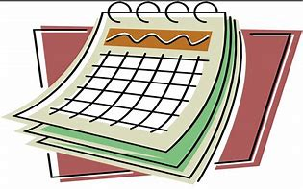
Dates for the Diary
Monday 18th April 2022 – Start of term 4
Thursday 12th May 2022 – Electronic copies of Pupil Reports issued to Parents from this date
Monday 23rd May 2022 – P4 Virtual Class Assembly
Wednesday 25th May 2022 - Parent Consultations via TEAMS 6-8:30pm-Details to follow
Thursday 26th May 2022 - Parent Consultations via TEAMS 4:15-6:45pm-Details to follow
Thursday 2nd & Friday 3rd June 2022 - School Closed to Pupils & Staff Queen’s Platinum Jubilee
Thursday 9th June 2022 – Fishermoss Family Community Clean Up! Pop along anytime between 4:30-7:30pm to join us. Meet at school-Details to follow
Thursday 16th June 2022 - Current P1 to P6 Pupils meet their teacher for session 2022/23
Thursday 23rd June 2022 - Primary 1 to Primary 7 Whole School Sports Event 10:30am Bourtree Park & Lunchtime Family Picnic Fishermoss School grounds→All Weather Permitting!
Friday 1st July 2022 – Last day of term
Homework
- Spelling will be taught in class every Monday. A list of spelling words will be in their yellow spelling jotter to practise at home. Spelling will be revisited throughout the week so please ensure children bring their jotter everyday to school.
- Reading will be heard in class throughout the week and will be noted in their homework diary. Alongside reading, your child will be given a Book Detective task to complete. Please ensure children bring their reading books and homework diary everyday to class.
- I will be uploading any other homework to our google classroom including our weekly spelling words, Big Talk homework to support writing in class and maths activities. This will be noted in their diary. If you have any problem accessing google classroom at home please let me know.

Numeracy
This term in maths we will be focusing on:
- Estimation and Rounding
- Time
- Measurement
- Expressions and Equations
- Angle, Symmetry and Transformation
- We will also continue to develop our mental and problem-solving strategies.

Literacy
This term in literacy we will be focusing on:
- Continue to develop our strategies to find and understand information during comprehension tasks.
- Making relevant notes under given headings when listening/watching and use these to understand what we have listened to or watched and create new texts. We will also be using our topic research to support writing.
- Continue to write for different purposes, focusing on using our success criteria and writing targets to make sure our writing is successful.
- We will also continue to use Jolly Grammar to develop spelling and grammar skills to inform reading and writing.

Topic
Our topic for this term will be ‘The Human Body’. We will develop our knowledge and understanding of the function of the skeleton and major organs of the human body and discuss what we need to do to keep them healthy. We will also explore our senses, the symptoms of some common diseases caused by germs and find out more about inheritance and how characteristics are inherited. We will also explore what is required for a healthy balanced lifestyle.
We will use this website to support our Health and wellbeing learning this term: https://rshp.scot/ . Please feel free to go onto the website and explore the resources that will support your child’s learning in class (click onto ‘level’ then First Level’).
If you have anything you wish to discuss, please don’t hesitate to get in touch through the diary or contacting the school and I will call back.
Kind regards,
Emily Blacklaws

