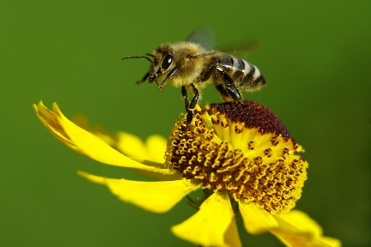
August 2022 Newsletter

Dear Parents/ Carers,

We are so pleased to welcome everyone to Primary 2/3! We look forward to getting everyone settled into the routines of our class and appreciate, that after the long summer break, some pupils may take longer to settle in than others. We also understand that parents and carers may have questions and anxieties about the return to school. We hope this newsletter might address some of these as it will give you an idea of the routines of our class and the aspects of learning that we will be exploring. If you have other questions, please phone the school and we will get back to you as soon as possible. Please remember that we will not be able to come to the phone when we are teaching the class. You can also email the school and your query will be forwarded to us. Alternatively, you could write a note in your child’s yellow homework diary as the diaries are checked most days for any correspondence.

Timetable/ Dates for the Diary
- Mrs Bryson is the class teacher on Monday/ Tuesday and Mrs Cameron is the class teacher on Wednesday/ Thursday/ Friday.
- PE is on a Monday and a Wednesday each week. Please ensure pupils wear something appropriate for gym when they come to school on those days. For example, they could wear black joggers or leggings and trainers.
- Miss Mellis will be in the class first thing on a Wednesday morning and will be teaching P.E. and music. Please note, Miss Mellis will collect the line on a Wednesday morning to bring the children into school.
- Mrs Gibb will support our class as a PSA for periods of time throughout the week as well as supporting the other Primary 3 class.
- Golden Time will be on a Thursday. We would ask that pupils do not bring toys in from home for Golden Time or on other school days.
- Parent Consultations Wednesday 5th October and Thursday 6th October, further details to follow.
- Friday 14th October – last day of term.

Curriculum
Over the first few weeks we will be assessing our children to see where they are in their learning and which learning gaps need to be addressed on our return to school. Our priority is to ensure that the children are happy and settled in the class so that they are ready to learn.

Literacy
- Reading will be heard in class and reading books will go home. Please don’t be alarmed if your child is given books that they have read before as it may be that they need to revisit some books to regain their confidence or because they need to build up particular skills in order to make further progress. Some guidance on how best to help your child with reading at home will follow later in the term.
- Pupils will continue to develop their knowledge of sounds and will practise blending sounds together to build words. P2 pupils will revise any single sounds that they are not yet secure with before moving on to learning about joined sounds. Most P3 pupils will revise any joined sounds that require consolidation before learning new sounds. They will also develop their awareness of the different ways to spell a given sound. For example, the A sound can be made by using an a with magic e, ai, or ay. P2 and P3 pupils will continue to develop their ability to accurately spell an increasing range of common words, as appropriate to their pace of learning.
- The children will be encouraged to write as independently as possible during all written tasks. For P2 pupils that are not yet ready for independent writing we will continue to scribe their ideas but encourage them to write any shorter, less complex words by themselves or to copy under/ over the teacher’s writing to help them further develop their letter formation and understanding of finger spacing and sentences. Pupils who are writing independently will be encouraged to use correct letter formation, to accurately use full stops and capital letters to mark sentences, to use consistently sized finger spaces and to apply their knowledge of sounds to help them attempt to spell the words that they wish to write. In addition to this, most P3 pupils will also be encouraged to correctly use an increasingly complex range of punctuation, to select the best vocabulary they can think of and to apply their knowledge of grammar rules when completing written tasks.

Numeracy
- Most P2 pupils will revise and consolidate their knowledge of numbers to 20 before moving on to addition and subtraction within 20. Pupils will complete tasks related to smaller or larger numbers as appropriate to their level of recall, knowledge and confidence on return to school. Please help your child to memorise the doubles to 10 and, once they can confidently recall these, they can learn the doubles to 20 e.g. 1+1=2, 2+2=4……10+10=20. Being able to rapidly recall these number facts will greatly assist your child with addition and subtraction work and help them develop good mental maths strategies e.g. if a know 8+8=16, then 8+7 must make 1 less, so the answer is 15.
Most P3 pupils will revise their knowledge and understanding of numbers to 100, before moving on to exploring numbers to 1000. P2 and P3 will also develop their knowledge of money (from 1p to £2) and time (o’clock, half past), differentiated as appropriate.

Topic
Our topic this Term will be Communities where the children will learn more about the local area and develop their map and geography skills. They will also learn how they can help to look after their community and wider environment and how people’s needs are met within their local community.

Homework
- Spelling/ Phonics homework will be sent home once a week when we have assessed which sounds each child can recall, recognise and form correctly. More information to follow.
- Reading will be sent home and again, once we have grouped the children accordingly, each group will have set reading days. Reading tasks will be set and recorded in the homework diaries. On occasion, because of Bank holidays or Inservice days, your child’s reading days will be different to the normal days, but this will be clearly recorded in your child’s homework diary.

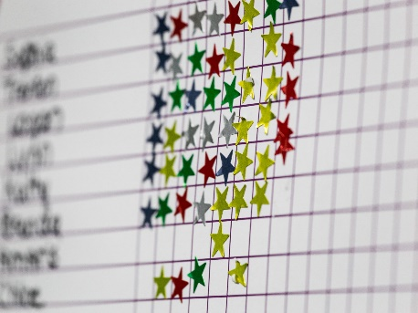
Our Class Charter
The children worked hard to create their own set of rules for the class. Our class charter is
- Persevere – don’t give up!
- Listen to others.
- Use an indoor voice.
- Have good manners.
- Be kind and gentle.
- Be honest.
- Look after property.
- Work hard.
- Be patient.
- Be helpful.
- Look after each other.

The children will also earn marbles for the class jar if they are observed following the class rules. This helps the class to work towards earning a class treat!
We would appreciate it if you would discuss the importance of following the class charter and school’s golden rules. The golden rules can be found on the first page in your child’s homework diary. Please can you and your child sign and date them as soon as possible. Thank you for your co-operation!

Learning Celebration Books
In P2 the children will begin to record learning/achievements that they are proud of in Learning Celebration Jotters. They will bring them home for you to look at, add a little comment to and then they must be returned to school. These books will come home as and when your child, whether P2 or P3, wishes to share a particular piece of learning with you.

Helpful tips
- We are continuing to practise good hygiene habits and wash hands regularly throughout the school day. If you have concerns about your child using the school soap, please feel free to provide an alternative soap for your child to use.
- Please supply your child with a freshly filled water bottle each day. As we are a health promoting school, remember that water is the only drink which can be taken into the classroom and to clearly label your child’s bottle with their name and class. Bottles containing juice will need to stay at the pegs during class time.
- Labelling all school clothing, equipment and shoes is useful even though pupils won’t be changing for gym. It would amaze you how things can go walk about! Labelling outdoor jackets is also useful as children do accidentally leave jackets outside if they take them off after getting too hot and forget to bring them back in. If they are clearly labelled, it is much easier for the jacket to find its way back to the owner!

If there is anything else we can help you with or something you wish to discuss, please don’t hesitate to get in touch,

Best Regards
Mrs Bryson and Mrs Cameron

