P4/5 Term 1 Newsletter
Weekly timetable
Monday- French (Miss Ruxton)
Tuesday – music (Miss Mellis) Assembly pm
Wednesday - PE
Thursday – Rugby (fist 4 weeks of term)
Friday – PE

August 2022

Dear Parents/Carers,
I hope you all had a lovely summer and are starting to get back into a routine again after the holidays. It has been lovely hearing all about everyone’s summer holidays.

Health and Wellbeing
Over the next couple of weeks, we will be spending time getting to know each other, reminding ourselves of the school rules and routines and we have worked collaboratively to create our own P4/5 class charter. This will be used alongside the school Golden Rules.:
- We are gentle
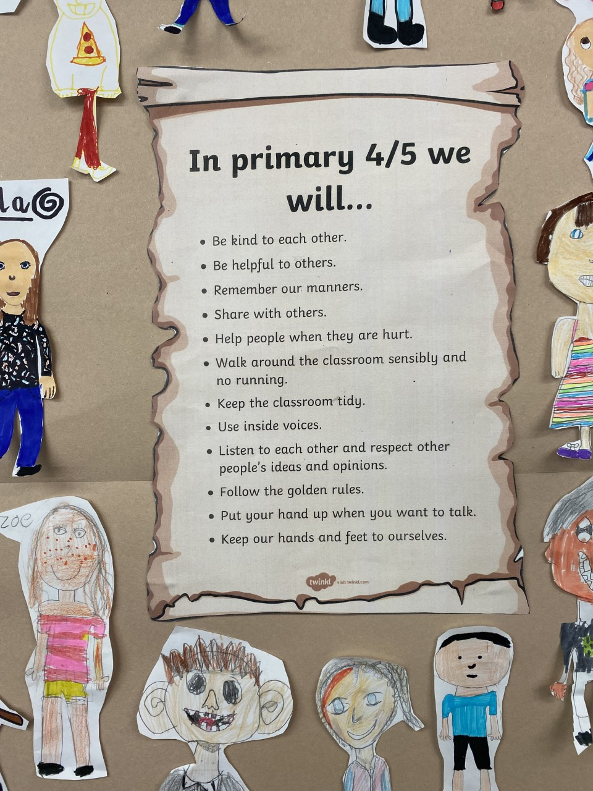
- We are kind and helpful
- We listen
- We are honest
- We work hard
- We look after property
There will also be a focus on team building, co-operation and working as part of a group to carry out various tasks and activities.

Literacy
P4
The focus within listening and talking will be Learning how to listen to others, take turns to share ideas respectfully during group/ whole class discussions. They will also be working fluency and exploring the role and impact of punctuation when reading.
During writing tasks, they will be working on planning and organising their ideas to ensure they write in a logical order. There will also be an emphasis on checking their work independently to ensure they have met the success criteria.
P5
The focus will also be within listening and talking to listen and value other people’s contributions and ideas during group/whole class discussions.
They will be considering the purpose and main ideas when reading new and unfamiliar texts.
During writing tasks, the focus will be on trying to include a range of punctuation, using paragraphs to separate their thoughts and ideas and proof- read their work to ensure that it makes sense. They will also be independently checking their work to ensure they have met the success criteria before handing it in.
Both groups
Will be extending their ability to answer questions across a range of different contexts. Spelling rules and sounds for both P4’s and P5’s and will be taught on a Monday and a list of words will be sent home for the children to practice during the week. These will also be reinforced in class. Please try and practise these regularly at home too as repeating little and often is the most effective!

Numeracy
P4;
Will be consolidating and developing their knowledge of place value to 1000. They will also be exploring addition and subtraction of two-digit numbers to 100.
P5;
Will also be consolidating and developing their knowledge of place value to 10000. They will also be exploring addition and subtraction sums with numbers up to 10,000.
Both groups
Both groups will be learning about how maths impacts our everyday life and how to estimate and round numbers up or down.

Topic
Our topic this term we will be learning all about ‘Pollution and Conservation’. We will be looking at the environmental impact of human activity on our planet and what effect this is having on wildlife especially endangered animals. We will be exploring what we can do around the school, local area and the planet.

P4/5 are taking responsibility for the ‘Shoe box Appeal’ this year. This will involve presenting to the rest of the school about what it is and how they can get involved, organising and distributing the shoe boxes and checking them before they get collected. More details of this will follow in due course.

Homework
Reading
Reading groups will be heard on either Mondays and Wednesdays or Tuesdays and Thursdays and your child will also have a weekly book detective task to accompany their reading. All book detective tasks should be completed in homework jotters.

Homework grid
A termly homework grid will be issued at the start of each term and this terms one has been stuck into the homework jotters this week. Pupils should aim to complete 1 or 2 per week. The grids include a range of different activities including some numeracy, literacy and health and wellbeing.
Google classroom
The class have been trying to get logged into GLOW this week and have been asked to change their password. Some of the pupils were having trouble getting logged on and this should be sorted out very soon.
The weekly spelling words and any other homework tasks will also be added to our class Google classroom site (accessed via GLOW). Photographs and any other information about the learning taking place in P4/5 will also be added to google classroom. A copy of the homework grid is also on there too.

Important information
- Please could you discuss with your child, and both sign the school
Golden Rules which are located at the front of the homework diary.
- There will also be a behaviour, attitude and effort report coming home week beginning 8th October in your child’s homework diary. Please add a comment in the space given.
- Learning Celebration Books are an important part of how the children can record their achievements which they are proud of. The children may choose to take them home at any time to share with you. Please take a minute to write a comment in their book and add any achievements that happen out of school too. Please return them to school asap.
This Photo by Unknown Author is licensed under CC BY-NC
- On PE days the pupils can either come to school in their school jumpers with joggers/leggings and trainers or change into these at school,
- All pupils require the following items daily; their homework diaries and green folder, a water bottle and a waterproof jacket.
If you have any questions, queries, or concerns about your child then please either write it into your child’s homework diary or contact the school office and I will get back to you as soon as I can.
Kind regards
Miss Sangster

