Fishermoss Parent Staff Council GM
24/11/2022
19:00
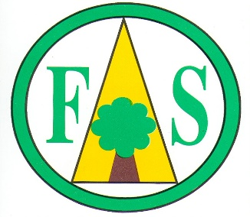

AGENDA

- Welcome (MM)

- Previous Minutes (LSV)

- Chair Update (MM)

- Head Teacher Update (MF)

- PVG / Disclosure Scotland Update & Approving new policies (LSV)

- Events (MM)
- Xmas Fayre (2nd December)
- Fishermoss has got talent
- AOB (MM)

