Welcome back after the October break. The children have settled well back into class.
Primary 2 Newsletter
Term 2
This is a very busy and exciting term with lots of lovely things planned.
Maths
In maths children will be continuing to work on time and look at calendars and months of the year. The children will also learn about the changes in the seasons. We will also be looking at 2D shape naming them and their properties.
Mrs Muir will continue to work on addition and subtraction within 20, working towards the next topic- numbers to 100.
Health and Wellbeing
The children will continue to learn about how to keep themselves safe in a range of situations such as Bonfire night, water safety and general safety in the home. We are hoping to have a visit from a fire crew along with their fire engine on Monday the 28th of November. I’m sure the children will learn a lot and have lots of interesting questions.
Spelling
Children will continue to be given words home on a Monday. Please try reading these and completing the task described or selecting one of the spell well activities on the leaflet provided.
Reading
In reading, please continue to encourage children to track words with their fingers as they read and when they listen to you reading. Mrs Muir will shortly be sending home key words from children’s current books (Offord Reading Tree), to help children recognise these frequently occurring words, which will significantly support reading attainment.
Topic
We are continuing our Day and Night topic, linking it to what we are learning in maths and further work on shadows. We will be looking at nocturnal animals and much more.

Wildlife Garden
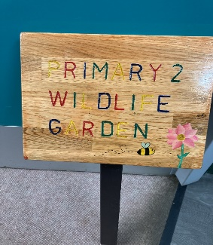
The children have been busy planning what they would like to do to improve our P2 wildlife garden and have created some wonderful drawings of their plans. They have also been busy planting bulbs which we will continue to look after and watch grow. We received a beautiful sign for the Wildlife Garden made for us by The Men Shed in Stonehaven and the children wrote some lovely thank you letters thanking them for their fabulous gift.
We plan on creating some mini beast homes and make the area more appealing to the insects and other wildlife.

House keeping
We are still finding clothing daily that is not named. It would be a huge help if all jumpers, jackets and water bottles could be named. This saves us wasting so much teaching time trying to locate the owners. Thank you in advance.
If you ever want to contact us feel free to email school, call or leave a note in your child’s homework diary. Make sure your child tells us you have written to us as despite our best efforts, we may accidently miss notes.

DATES FOR THE DIARY
Thursday 17th November In -service Day school closed to pupils
Friday 18th November In -service Day school closed to pupils
Wedneday 21st December Cinema Trip (more to follow)
Thursday 22nd of December Church Service

