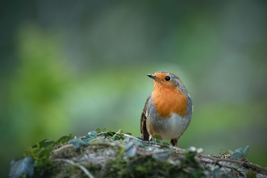
January 2023 Newsletter
Dear Parents/ Carers,
We are so pleased to welcome everyone back after the holidays. We hope you all had a wonderful Christmas and wish everyone a happy New Year!
This newsletter should give you an overview of what we will be learning about this term. If you have any questions at any point during the term, please phone the school and we will get back to you as soon as possible. Please remember that we will not be able to come to the phone when we are teaching the class. You can also email the school and your query will be forwarded to us. Alternatively, you can write a note in your child’s yellow homework diary as the diaries are checked most days for any correspondence.
Timetable
- Mrs Bryson is the class teacher on Monday/ Tuesday and Mrs Cameron is the class teacher on Wednesday/ Thursday/ Friday.
- PE is on a Monday and a Wednesday each week. Please ensure your child wears something appropriate for gym when they come to school on those days. For example, they could wear black joggers or leggings and trainers.
- Miss Mellis will be with class first thing on a Wednesday morning and will be teaching P.E. and music. Please note, Miss Mellis will collect the line on a Wednesday morning to bring the children into school.
- Mrs Gibb will support our class as a PSA for periods of time throughout the week as well as supporting the other Primary 3 class.
- Golden Time will be on a Wednesday. We would ask that pupils do not bring toys in from home for Golden Time or on other school days.
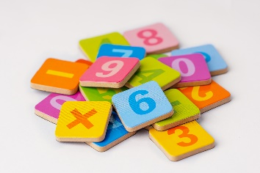
- Plastic Free Fridays will start this term. Children who wish to sign up to take part in this should bring in a snack that doesn’t contain or require single use plastic. Please see the email sent by school for further information.

Curriculum
Literacy
- Reading will continue to be heard in class and reading books will go home. We encourage our pupils to apply their reading skills when working across the curriculum and to all pupils will complete an increasing range of comprehension tasks. We will also be reading a class novel. This term it will be “The Ice Monster” by David Walliams, which should provide lots of scope for enjoyment, discussion and vocabulary development.
- P2 Pupils will continue to develop their knowledge of joined sounds and will practise blending sounds together to build words. P3 pupils will continue to revise and extend their knowledge of spelling patterns. P3 pupils will also have a specific common word focus each week and will complete common word spelling tasks in class daily.
- Spelling homework will continue to be posted every Tuesday to Google Classroom. Remember to click “hand in” when your child has completed this or, if you prefer, you can upload photographs of the activity they have completed.
- In writing this term, we will be focusing on imaginary writing. We will also complete written tasks which link to our topic, Early Man. At all times we will be encouraging the children to write as independently as possible, applying their knowledge of spelling and grammar to their written tasks. All pupils will be supported to accurately spell an increasing range of common words during written tasks and we will continue to encourage correct letter formation. Please support you child with this if they do any writing at home. Remind them that all letters should be formed in one movement, without lifting the pencil, and letters and numbers should not be written starting from the bottom up. Starting the letter or number in the correct place can help your child to have fewer reversals in their writing. It is also a good habit to establish as it will make things easier for your child when they begin to learn joined handwriting.
Numeracy
- Most P2 pupils will continue to practise subtraction within 20, exploring mental strategies and the use of concrete materials, such as a number line, to help them work out the answers. They will increase their knowledge of numbers to 100, applying their knowledge and understanding to complete a range of tasks. Some pupils will also be introduced to the concept of multiplication and division this term and begin to work with numbers beyond 100.
- P3 pupils will continue to develop their knowledge and understanding of numbers to 1000, applying this knowledge to complete a range of tasks. They will also focus on learning the 2,3,4,5 and 10 times tables and using this knowledge to solve division sums, with and without remainders. P3 pupils will develop their ability to read and correctly interpret maths questions from a textbook and to neatly set out their working in a jotter.
- All pupils will complete tasks related to smaller or larger numbers as appropriate to their level of knowledge and understanding. The whole class will continue to develop their knowledge of time and length (standard and non-standard units of measure) with tasks differentiated as appropriate.
Topic
This term, we will be learning about Early Man. We are sure the children will really enjoy this topic and we hope to do lots of hands-on craft, technology and art-based tasks linked to our learning about Early Man. We will also be exploring the Scots language and learning about Scottish traditions for Burns Night which is on the 25th of January. All pupils will be asked to learn a Scottish poem to recite to celebrate the Scots language. Pupils will be able to recite their poem with a partner or in a small group if they feel nervous about reciting it on their own.
Helpful tips
- Welly boots can be worn on wet days but please put another pair of shoes into your child’s bag for them to change into when they get to school.
- Please supply your child with a freshly filled water bottle each day. As we are a health promoting school, remember that water is the only drink which can be taken into the classroom and to clearly label your child’s bottle with their name and class. Bottles containing juice will need to stay at the pegs during class time.
- Please continue to label all school clothing, equipment and shoes. If they are clearly labelled, it is much easier for the item to find its way back to the owner! We appreciate it! Thank you!
Dates for the diary
- Wednesday 1st of February - Show and Tell Curriculum Event 4-6.30pm – more information to follow.
- 8-10th of February – Local holiday – school closed.
- 13th of February – Midterm holiday – school closed.
- 14th and 15th of February – In-Service days – school closed to pupils.
- 31st of March – end of term.
If there is anything else we can help you with or something you wish to discuss, please don’t hesitate to get in touch,
Mrs Bryson and Mrs Cameron

