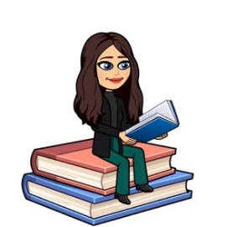

January 2023
Primary 5 Term 3 Newsletter
Dear Parents/Carers,
Happy New Year! I hope you all had a lovely Christmas break.
Reminders:
- Pupils are encouraged to take a pencil, rubber and any stationery items they require to school, water bottle, and a jacket.
- Pupils should bring their reading book and homework diary every day to school.

Weekly timetable:
Monday: | French (with Ms Ruxton)  Spelling words issued in spelling jotters to practise at home.
Tuesday: | P.E (Racquet skills with Miss Mellis)
Wednesday | Writing  Assembly
Thursday: | P.E  Music (Kodaly first 6 weeks)
Friday: | Golden Time

Dates for the Diary
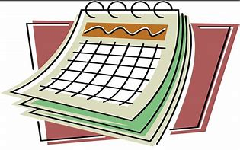
- Mon 9th January - Pupils and Staff return to school.
- Wk beginning Mon 23rd January - Interim Pupil Report.
- Wed 8th - Mon 13th February - Mid Term Holiday - School closed to pupils and staff.
- Tues 14th & Wed 15th February - Staff In-Service Days - School closed to pupils.
- Fri 10th March - School Photographer - Sibling or individual Photographs.
- Wed 15th March – P5 Class Assembly (details to follow).
- Fri 17th March – Comic Relief Red Nose Day ‘Dress as you Please’
- Wk beginning Mon 27th March - Effort/Attitude/Behaviour comments in homework diaries.
- Fri 31st March - Last day of Term 3
Homework
- Spelling will be taught in class every Monday. A list of spelling words will be in their yellow spelling jotter to practise at home.
- Reading will be heard in class throughout the week and will be clearly noted in their homework diary. Alongside reading, your child will be given book detective tasks to complete. Book detective tasks can be found at the start of the homework diary (page 16) and can be completed in their homework jotter.
- I will be uploading any other homework to our google classroom including Big Talk homework to support writing in class and maths activities. If you have any problem accessing google classroom at home please let me know.

Learning Celebrations Books
Pupils have the opportunity throughout the year to bring home their Learning Celebration books to share and celebrate their learning and achievements with you. You are welcome to write a comment in their book then please return to school.

Numeracy
This term in maths we will focus on:
- Multiplication and division.
- Multiples, factors and prime numbers.
- Fractions, decimal fractions and percentages.
- Collecting and displaying information and interpreting data.
Literacy
This term in literacy we will focus on:
- Continuing to develop strategies to find information in texts during comprehension tasks and answer different types of questions.
- Using our success criteria to create successful pieces of both imaginative and functional writing.
- Our literacy work will link with our topic as we study Charlie and the Chocolate Factory considering the style of the author, his use of language and characterisation.
- We will also continue to use Jolly Grammar to develop spelling and grammar skills.

Topic
Our topic for term 3 is ‘Charlie and the Chocolate Factory’. Through this topic we will learn about the history of chocolate and Fairtrade. We will be developing our enterprise skills through planning and organising a Fairtrade event at school and creating and marketing a new chocolate bar.

Health and Wellbeing
This term our focus will be on food and health. We will be developing our knowledge of healthy living and a balanced diet through the wellbeing plate.

If you have anything you wish to discuss, please don’t hesitate to get in touch through the diary or contacting the school and I will call back.
Kind regards,
Emily Blacklaws

