School Uniforms
How exciting, it’s almost time for your child to go to school!! Below are pictures of the different types of school uniforms available and the sizes. We hope this information helps you in choosing which size of uniform is best for your child.
The sizes are as follows
Age 3-4, height 104cm's, chest 22/25 inches.
Age 5-6, height 116cm's, chest 25/28inches.
Age 7-8, height 128cm's, chest 28/30 inches.
Last date for ordering is beginning of June.
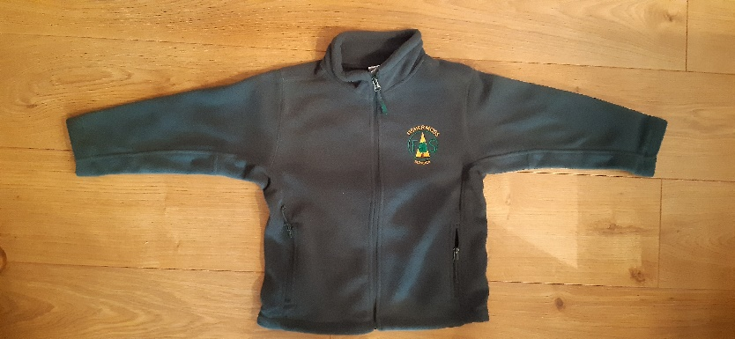
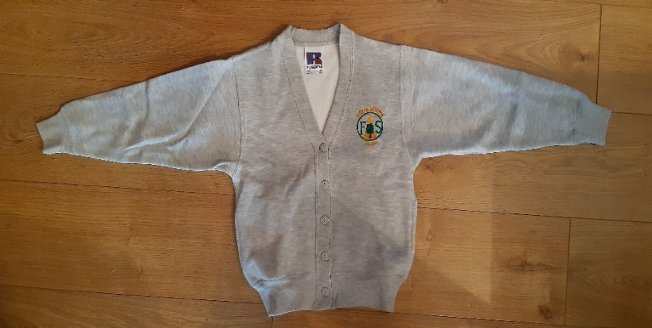
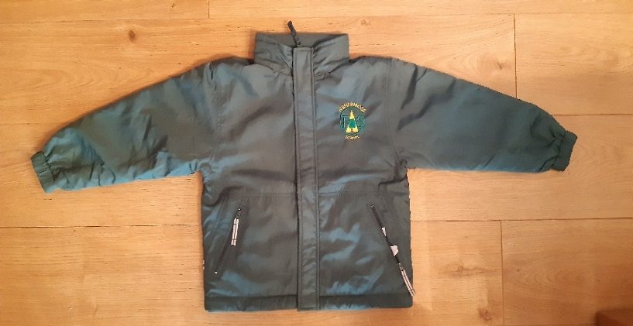
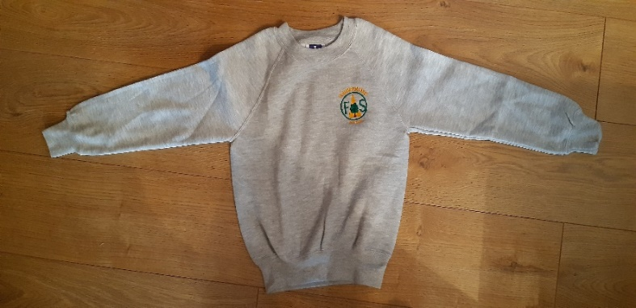
The order form can be found on our school website https://fishermoss.aberdeenshire.sch.uk/school-uniform/
