Fishermoss Parent Staff Council GM
14/06/2023
18:00
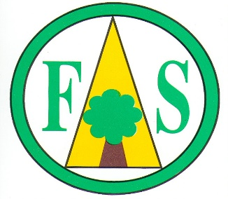

AGENDA

- Welcome (MM)

- Previous Minutes (LSV)

- Chair Update (MM)

- Head Teacher Update (MF)

- Events (MM)

- AOB (MM)

