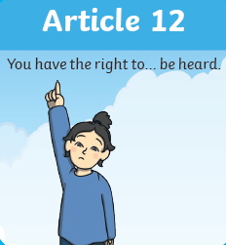

**Children in School as Rights Holders**

Be kind and in what we do and say.

•Respect other peoples’ personal space and use kind hands and feet

•Respect other children’s right to learn by working quietly and not distracting others

•In school always listen to adults and to each other

•Show respect with eye contact for a person to know you are listening

•Be polite and welcoming to others

•Respect school and other peoples’ property

•Offer to help others when needed

•Try to make school a happy and enjoyable place for everyone

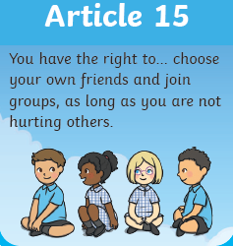 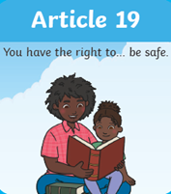 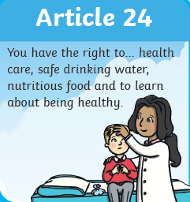

**Adults in School as Duty Bearers**

•Listen to and respect children’s thoughts and ideas

•Encourage and support children in their work

•Make sure the class is calm and quiet for learning.

Help children work without distraction

•Teach new and interesting things

•Make learning fun

Make time and space for rest and play

Make opportunities for being active and healthy

•Help children if they need it

•Encourage children to improve their skills

•Reassure children if they’re worried

Try to make school a happy and enjoyable place for everyone

