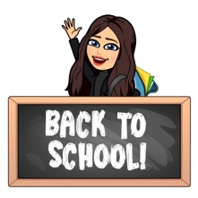

August 2023
Primary 4 Newsletter
Dear Parents/Carers,
Welcome to Primary 4! I am Miss Blacklaws and I will be your child’s P4 teacher. I hope you all had a fantastic summer break. It has been great to welcome your child back to school after the holidays and hear all their holiday news. The class have settled in well into our new routine and are looking forward to our learning this term.
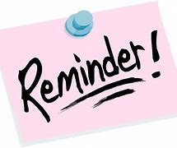
Reminders:
- Pupils are encouraged to take a pencil, rubber and any stationery items they require to school, water bottle, and a jacket.
- Pupils should bring their reading book and homework diary each day.
- This term we will have P.E on Tuesdays and Thursdays. This will take place outdoors. Could I please encourage pupils to be appropriately dressed for outdoor exercise.
- Pupils have the opportunity throughout the year to bring home their Learning Celebration books to share their learning and achievements with you. You are welcome to write a comment in their book then please return to school.

Weekly timetable:
Monday: | Spelling words issued in spelling jotters to practise at home.  French with Ms Ruxton
Tuesday: | P.E with Mrs Storey
Wednesday | Assembly
Thursday: | P.E with Miss Blacklaws
Friday: | Library  Golden Time

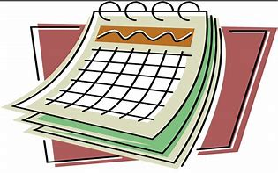
Dates for the Diary
- Tuesday 22nd August - Start of Term 1 for Pupils
- Friday 13th October - Last day of Term 1
- Monday 16th - Friday 27th October -Autumn Holiday
- Monday 30th October – Start of Term 2
- Thursday 16th November - Staff In-service Day (school closed to pupils).
- Friday 17th November - Staff In-service Day (school closed to pupils).
- Friday 22nd December - Last day of Term 2
- Monday 25th – Friday 5th January-Winter Holiday
Homework
- Spelling will be taught in class every Monday. A list of spelling words will be in their yellow spelling jotter to practise at home. Spelling will be revisited throughout the week so please ensure children bring their jotter everyday to school.
- Reading will be heard in class throughout the week and will be noted in their homework diary. Alongside reading, your child will be given a Book Detective task to complete. Book detective tasks can be found at the start of the homework diary (page 16) and can be completed in their homework jotter.
- I will be uploading any other homework to our google classroom including our weekly spelling words, Big Talk homework to support writing in class and maths activities. If you have any problem accessing google classroom at home please let me know.

Numeracy
This term in maths we will focus on:
- Place value with numbers to 1000.
- Addition and subtraction of whole numbers up to 1000.
- Estimation and rounding.
- Time
- We will also be developing our mental and problem-solving strategies.

Literacy
This term in literacy we will focus on:
- Independently using the correct punctuation in our writing. We will focus on both functional and imaginative writing through creating texts linked to our class topic.
- Developing our understanding in reading and comprehension through responding to different types of questions on texts we have read.
- Developing our note taking skills.
- We will also use Jolly Grammar to develop spelling and grammar skills.

Topic
Our topic for term 1 and 2 is Scotland. We will be developing our use of mapping skills and exploring the features of the landscape, looking at the various ways in which the land has been used in our local area.
Through our class topic we will be developing our knowledge of Scotland’s main cities, rivers and lochs. We will also use our research skills to find out about the different types of food produced in Scotland, famous Scots and Scottish landmarks.
P4 Class Charter:
This week, P4 have worked together as a class to discuss what makes a super learning environment at school.

The children have been learning about The United Nations Convention on the Rights of the Child (UNCRC). Our class charter is a set of statements we agreed were important in class to feel safe and happy at school. We decided on the following rights and statements for our P4 class charter:

Every child has the right to an education - Article 28 | - We will always work hard, persevere, and try our best.  - We will be helpful and respectful to others when they are working.  - We will listen carefully to others.  - We will look after the resources in our classroom.  - Teachers will plan lessons and activities for us to learn.  - Teachers and PSA will help pupils when they are stuck.
Every child has the right to rest, relax, play and to take part in cultural and creative activities - Article 31. | - We will take care of our toys and equipment.  - We will take turns and include everyone in our games.  - We will have fun and help people who are feeling sad.
Children have the right to the best health care possible, clean water to drink, healthy food and a clean and safe environment to live in. All adults and children should have information about how to stay safe and healthy - Article 24 | - We will make sure our classroom is tidy.  - We will fill up our water bottles and drink lots of water to stay hydrated.  - We will take part in P.E.  - We will learn how to stay safe and healthy.
All children have all these rights, no matter who they are, where they live, what language they speak, what their religion is, what they think, what they look like, if they are a boy or girl, if they have a disability, if they are rich or poor, and no matter who their parents or families are or what their parents or families believe or do. No child should be treated unfairly for any reason - Article 2 | - We will be kind to everyone and treat each other equally.  - We will be fair and include everyone.

If you have anything you wish to discuss, please don’t hesitate to get in touch through the diary or contacting the school and I will call back.
Kind regards,
Emily Blacklaws

