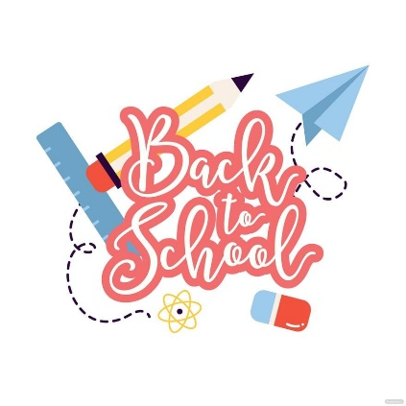

October 2023
Dear Adults,
I hope you all had a fabulous October break. The pupils seem excited to be back and share their holiday news. Everyone has settled back into school routine well which is lovely to see.
Please ensure that all belongings are named: school clothing, jackets, bags, shoes, pencil cases, packed lunch boxes, and water bottles. This allows for easy return to the owner should anything get lost. It would be helpful if pupils come to school wearing shoes they can independently fasten.
Pupils are encouraged to bring a pencil and a rubber to school.

Numeracy
This term we will be exploring addition and subtraction within 20. This will be introduced using concrete materials to aid the learning. Pupils will also learn about 2D shape this term which can tie in nicely with lots of Christmas craft activities.

Literacy
Pupils will continue to develop their knowledge of sounds and blending sounds together to build words. Pupils will begin to learn about joined sounds such as ‘sh’ and ‘ch’. Phonics homework will be posted on Google classroom weekly. Further information will be posted alongside sounds and words for the week.
Reading will be heard in class and reading books sent home. I aim to hear each pupil read a minimum of twice a week but sometimes this is not possible due to other timetable commitments or one-off activities we can experience.
Please take the time to hear your young person read at home. It would be great if you could encourage and model sounding out words but if some are particularly tricky it is not an issue to tell them the word to support their reading.
Topic
Pupils loved our topic of Julia Donaldson last term and we will be continuing this in term 2. There are still so many great stories for us to explore and I know the class are looking forward to it.
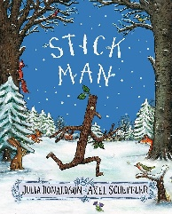
We will also be doing some science this term and learning about night and day.

P.E
This term P.E will take place on a Monday and Friday. This may take place outdoors and pupils should be appropriately dressed including footwear. In addition to timetabled P.E lessons, pupils will have opportunities for the Daily Mile and other outdoor activities throughout the week. Please ensure your child has weather appropriate clothing, and footwear, with them each day.
Weekly Timetable
Monday: PE with Mrs Storey
Tuesday:
Wednesday: Assembly
Thursday: RME with Mrs Rennie
Friday: Library, PE, Golden Time

Class Charter
- We are kind and look after others
- We are honest
- We look after property
- We play nicely and include others
- We tidy the classroom and other areas
- We listen carefully to others
- We try our best
These are linked to the following UNCRC articles:
Article 13 – The right to be listened to when sharing opinions
Article 29 – The right to an education
Article 31 – The right to play

Dates for the Diary
- Children in Need, Dress as You Please – Wednesday 15th November
- Staff In-Service Days – Thursday 16th and Friday 17th November
- PSC Christmas Fayre – Saturday 2nd December
- Christmas Cinema Trip – Tuesday 19th December
- End of term Christmas Church service – Wednesday 20th December
- Last day of term – Friday 22nd December

If you need to get in touch with me please e-mail the school office and it will be passed on, alternatively, pop a note in your young person’s diary and ask them to let me know.

Thank you all for your well wishes and congratulations about my wedding in the holidays. It was a beautiful day and the class all seem very excited that I now have a new name! I have reassured them that I will still answer to Miss Mellis as I know it will take some getting used to.
I am looking forward to a very exciting and busy Christmas term!
Thank you,
Mrs Taylor

