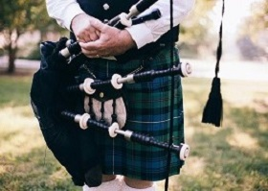

Join us and get making. Inspired by our national bard Robert Burns we will be doing some Scots themed creating.

This is a free session for children aged 5-12 years old. Booking essential.

**Burns Night Craft**

**Thursday January 25**

**4-5pm**