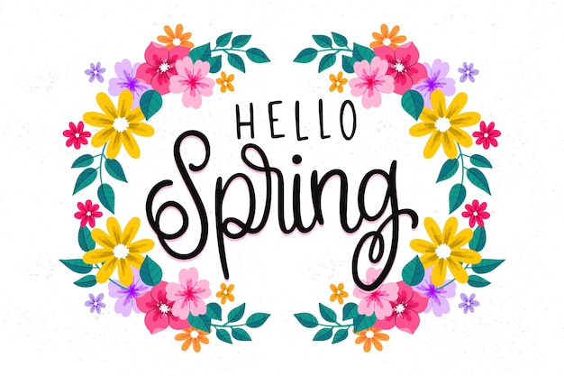

April 2024
Dear Adults,
I hope you all had a lovely Easter break. It’s a shame the weather wasn’t better but hopefully everyone managed some R&R regardless! The children have enjoyed sharing their holiday stories so far this week.

Please ensure that all belongings are named: school clothing, jackets, bags, shoes, pencil cases, packed lunch boxes, and water bottles. This allows for easy return to the owner should anything get lost.
It would be helpful if pupils come to school wearing shoes they can independently fasten. The classroom can be busy and I would hate for any accidents to happen by tripping over untied shoelaces if I haven’t managed to tie them as quickly as I would like.
Pupils are encouraged to bring a pencil and a rubber to school.

Numeracy
This term we be revising addition and subtraction within 20 and numbers to 100. It would be helpful if you could support this at home by asking simple questions as they come up such as “you have 4 lego bricks and I have 7, how many are there altogether?”
We will be exploring several practical maths topics this term too. Money, telling the time, measure, and data analysis.

Literacy
Pupils will continue to develop their knowledge of joined sounds – such as ‘ea’ and ‘oi’ - and blending sounds together to build words. Phonics homework will continue to be posted on Google classroom weekly. Further information will be posted alongside sounds and words for the week as appropriate.
Reading will be heard in class and reading books sent home. I aim to hear each pupil read a minimum of twice a week but sometimes this is not possible due to other timetable commitments or one-off activities on offer.
Please take the time to read with your young person at home. It would be great if you could encourage and model sounding out words but if some are particularly tricky it is not an issue to tell them the word to support their reading. Listening to your young person reading aloud and reading stories to them for enjoyment is very beneficial.

Topic
This term our topic will be Weather. We will be recording and measuring the weather, thinking about how it affects our daily lives, and exploring climates across the world.

Health and Wellbeing
In health and wellbeing this term, your young person will be taking part in RSHP lessons. The lessons for p2 are:
- My body
- Privacy
- Friends and friendships
- Looking after plants and animals
- People who help and look after me
All units are available for parents to view on the RSHP website, along with some useful links to support RSHP at home - https://rshp.scot/first-level/
P.E
This term P.E will take place on a Monday and Friday. This may take place outdoors and pupils should be appropriately dressed including footwear. In addition to timetabled P.E lessons, pupils will have opportunities for the Daily Mile and other outdoor activities throughout the week. Please ensure your child has weather appropriate clothing, and footwear, with them each day.

Weekly Timetable
Monday: PE with Mrs Storey
Tuesday:
Wednesday: Assembly
Thursday: RME with Mrs Rennie
Friday: Library, PE, Golden Time

Class Charter
- We are kind and look after others
- We are honest
- We look after property
- We play nicely and include others
- We tidy the classroom and other areas
- We listen carefully to others
- We try our best
These are linked to the following UNCRC articles:
Article 13 – The right to be listened to when sharing opinions
Article 29 – The right to an education
Article 31 – The right to play

Dates for the Diary
- Bank Holiday – Mon 6th May
- Dress as You Please Day – Fri 7th June
- School Summer Fayre – Sat 8th June
- Sports Day – Tues 18th June
- Last Day of Term – Fri 5th July
If you need to get in touch with me, please e-mail the school office and it will be passed on.
Thank you,
Mrs Taylor
